Messaging Categories
- MFPW messaging
- Action items
- Audience

MFPW Messaging
Post Text | Image Options
It’s Medicare Fraud Prevention Week! The week everyone can learn about protecting yourself, your friends, and your loved ones from scammers.  There are a lot of ways to participate so stay tuned in all week to the SMP Facebook page for different ideas to prevent, detect, and report Medicare fraud. #MFPW | 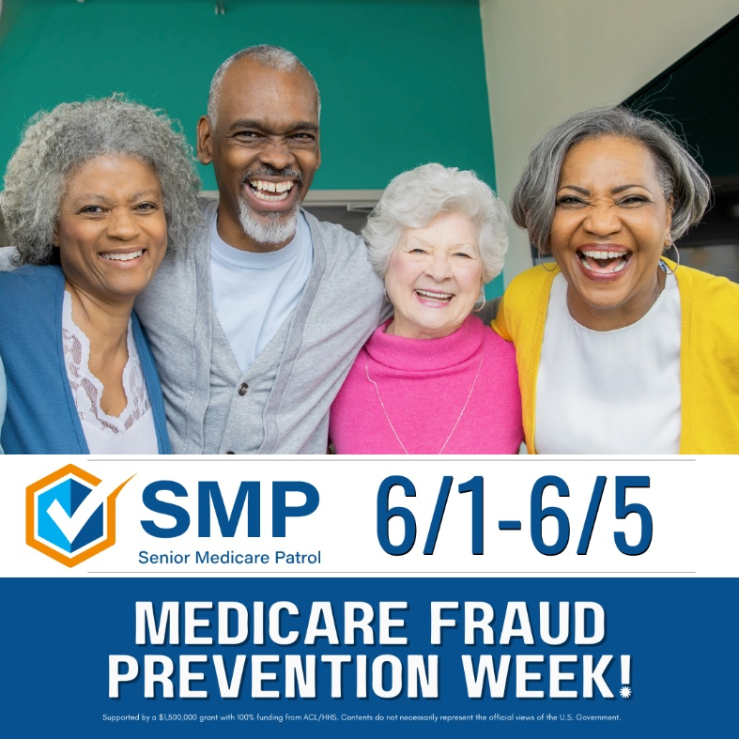
Happy 6/5! Most people become eligible for Medicare at 65 so we celebrate Medicare Fraud Prevention Week the week of 6/5 to help remember the steps to prevent, detect, and report Medicare fraud! #MedicareFraudPreventionWeek #MFPW

Action Messaging
Post Text | Image Options
Are you ready to be a fraud fighter? Create a free online account at Medicare.gov to be able to track claims and make sure what you are billed for is correct. #MedicareFraudPreventionWeek #MFPW | 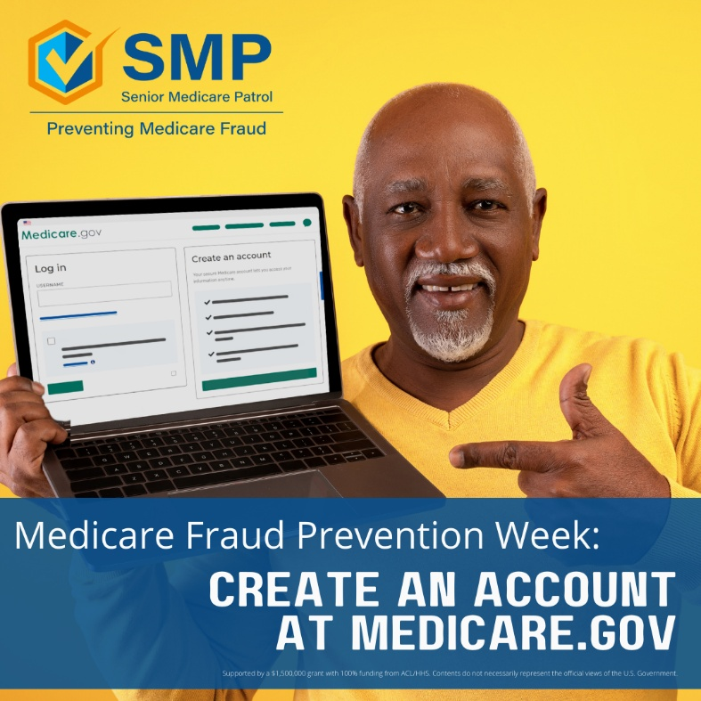
Do you know how to read a Medicare statement? If you don’t, this is a great time to learn!  Reading your Medicare statements that come in the mail every 180 days or anytime online at Medicare.gov is a great way to find and report suspected fraud.  The SMP has many tools to help you learn how to read your Medicare statements. Learn more https://smpresource.org/you-can-help/read-your-medicare-statements/.  #MedicareFraudPreventionWeek #MPFW | 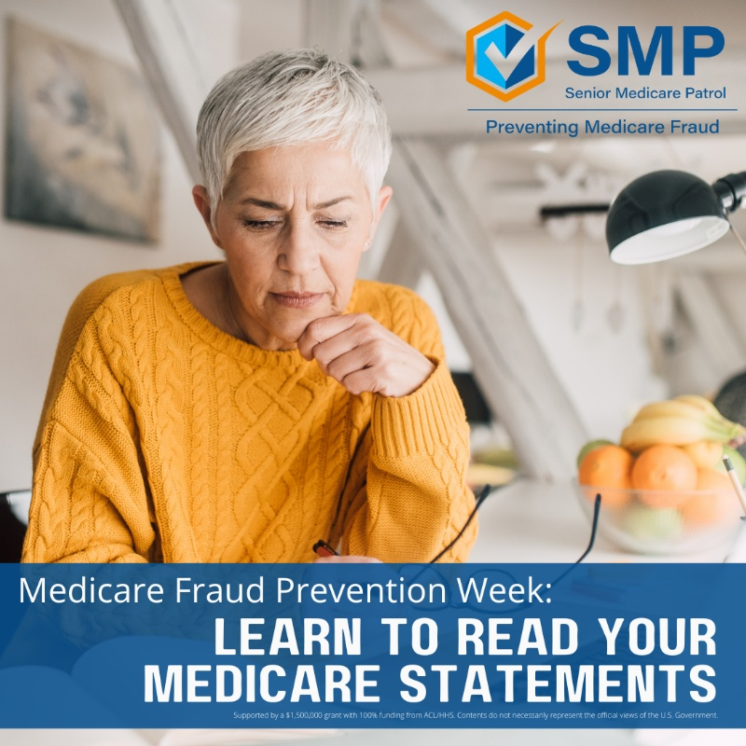
Guard your Medicare card. Don’t give your Medicare number to anyone over the phone. Don’t text it. Don’t use it to sign up for “free” offers. Saying no is the best defense against scammers. #MedicareFraudPreventionWeek #MFPW | 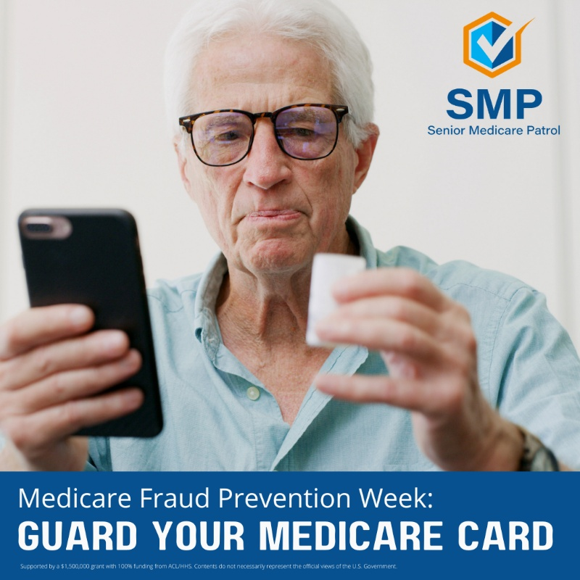
Request and use a My Health Care Tracker from the SMP and track what happens at appointments to then compare what you have written to what is billed on the Medicare Summary Notices (MSNs) and/or Explanation of Benefits (EOBs).  If you see something concerning, report it to the SMP.  #MedicareFraudPreventionWeek #MFPW | 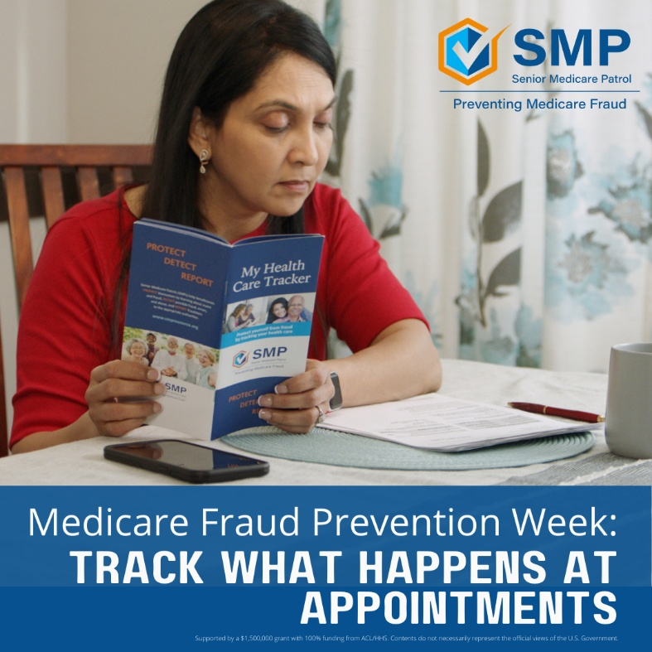
Download the SMP Medicare Tracker app to record what happens at health care appointments. Then compare what you have written with what is billed on the Medicare Summary Notices (MSNs) and/or Explanation of Benefits (EOBs).  If you see something concerning, report it to the SMP.  #MedicareFraudPreventionWeek #MFPW | 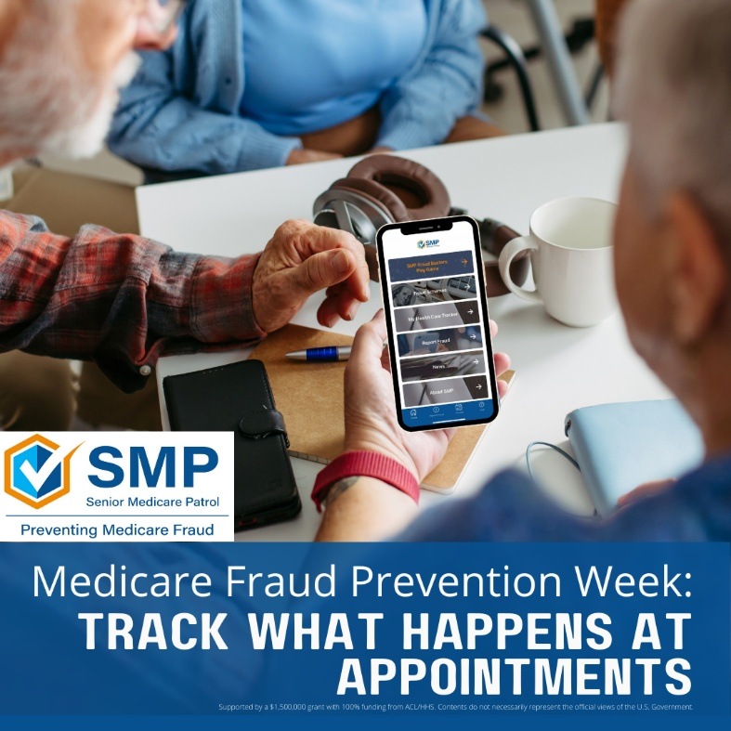
The most effective way to stop Medicare fraud from happening is to prevent it in the first place.  For situations you can't prevent, learning how to detect potential fraud, errors, and abuse is very important.  If you find something concerning on a Medicare statement or accidentally give out your Medicare information, report it! Don't hide it and don't be ashamed. Scammers are really good at what they do and the SMP is here to help.  #MedicareFraudPreventionWeek #MFPW | 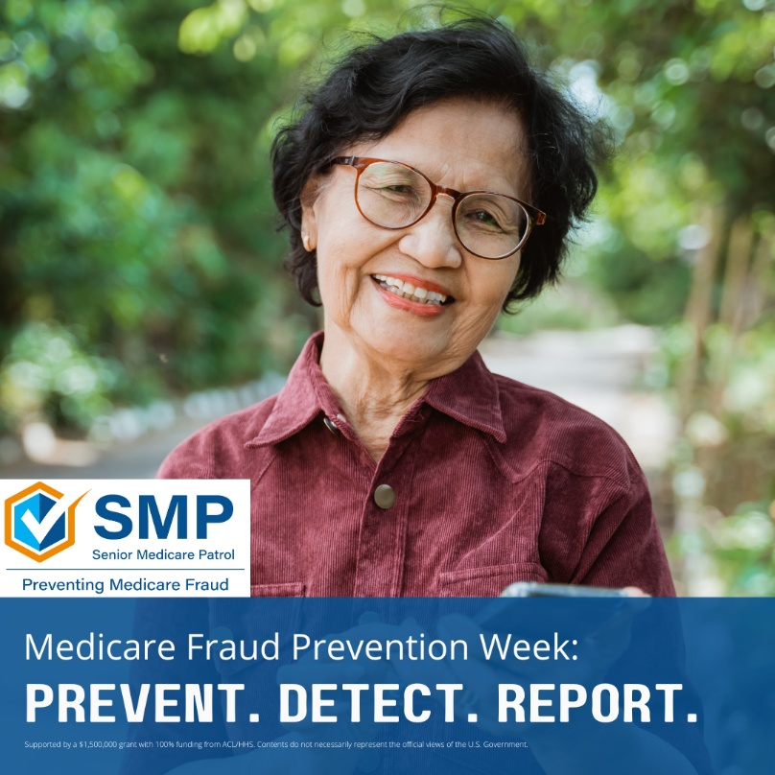

Audience
Post Text | Image Options
Scammers will use a lot of tactics to get your Medicare number, so be aware of their tricks. If it sounds too good to be true, it probably is. #MedicareFraudPreventionWeek | 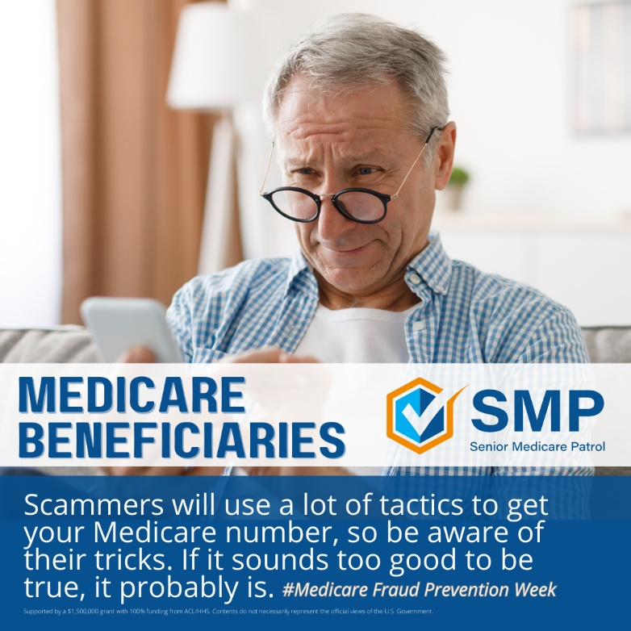
You might be offered “free” products like back or knee braces, food, or additional benefits for your Medicare number. That’s a scam. | 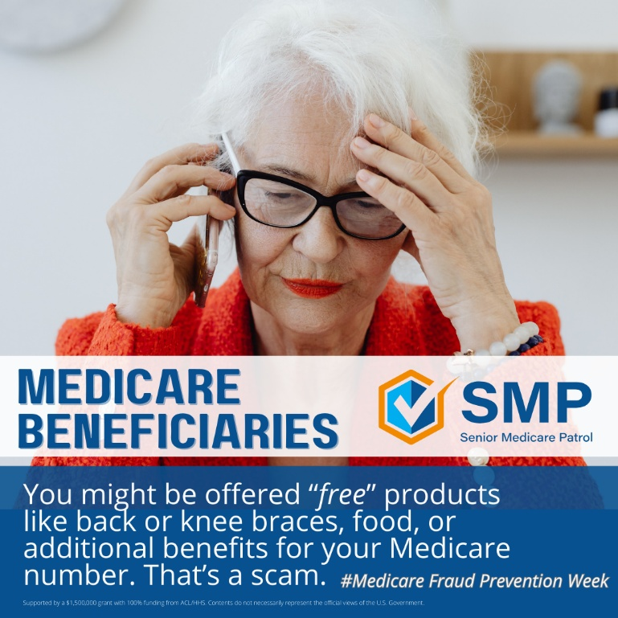
Families and caregivers, you can help protect your loved ones from being scammed. Talk to the older folks in your life about protecting their Medicare number like they would a bank account number. #MedicareFraudPreventionWeek | 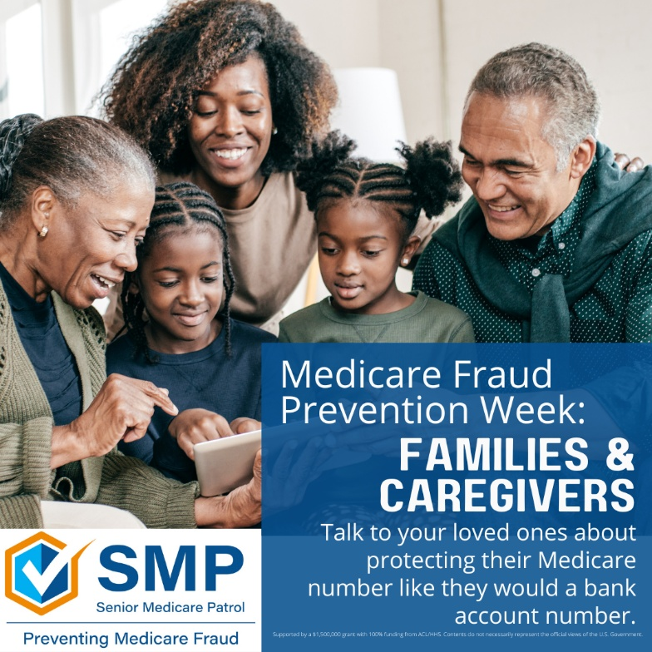
Sharing silly moments with family is important. Sharing Medicare numbers with people who ask for it over the phone, through email, or at the door is risky.  If you have a family member or take care of someone over 65, talk to them about never sharing their Medicare number to unsolicited requests. This is likely a scam and could lead to medical identity theft. #MedicareFraudPreventionWeek #MFPW | 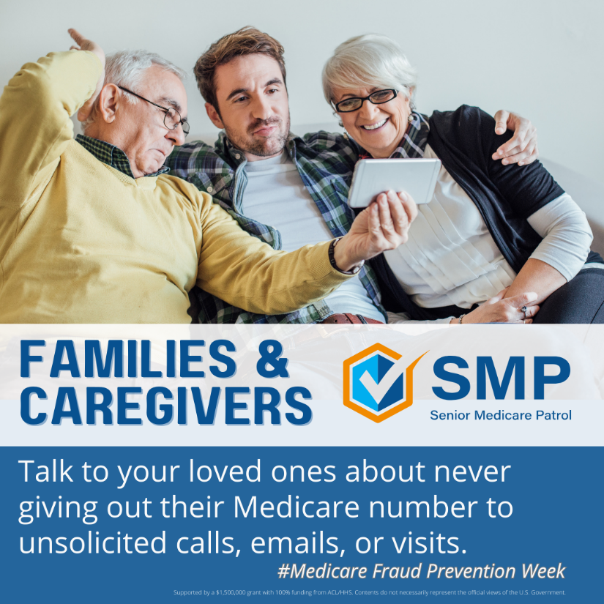
Partner agencies, celebrate Medicare Fraud Prevention Week by sharing SMP information on social media and refer your clients and consumers to the SMP! We can all work together to stop Medicare fraud. #MedicareFraudPreventionWeek #MFPW | 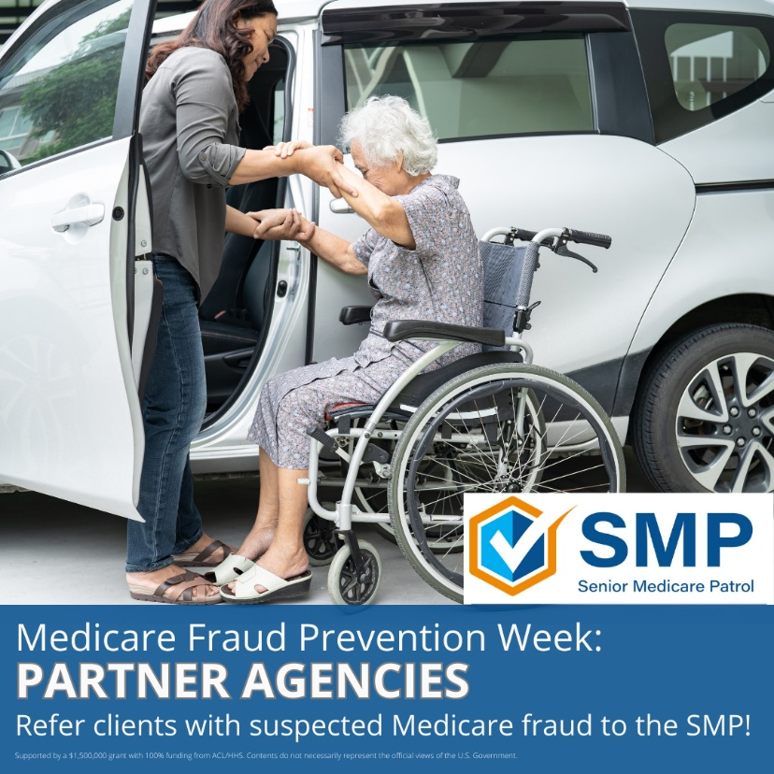
Do you work with folks who are 65 and older? The SMP would love to come speak with them about how to prevent, detect, and report Medicare fraud, errors, and abuse. #MedicareFraudPreventionWeek #MFPW | 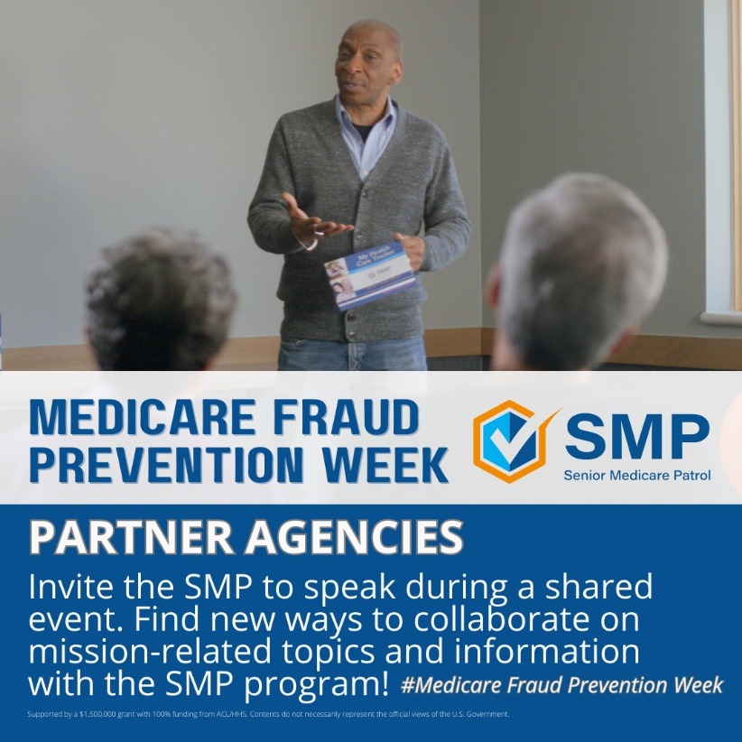
Health care professionals, stay alert for fax requests for DME, HIPAA, patient notes, or other items or services that you haven't talked to your patient about. Scammers are counting on your office to be busy and rush these through without confirming with the patient first. #MedicareFraudPreventionWeek #MFPW | 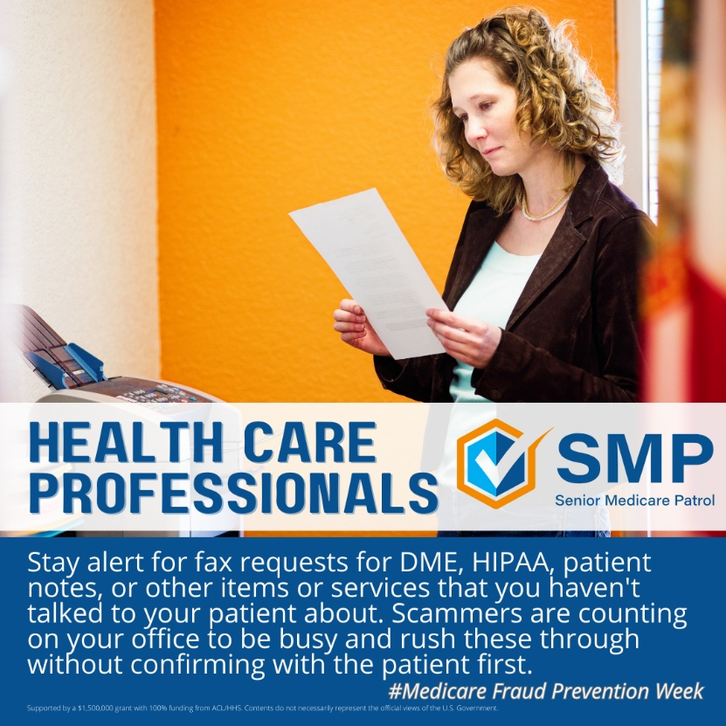
Talk to patients about common health care-related scams like back and knee braces, genetic testing, urinary catheters, and plastic Medicare cards. As a trusted source, you can help them learn about scams and how to protect their medical identity.  #MedicareFraudPreventionWeek #MFPW | 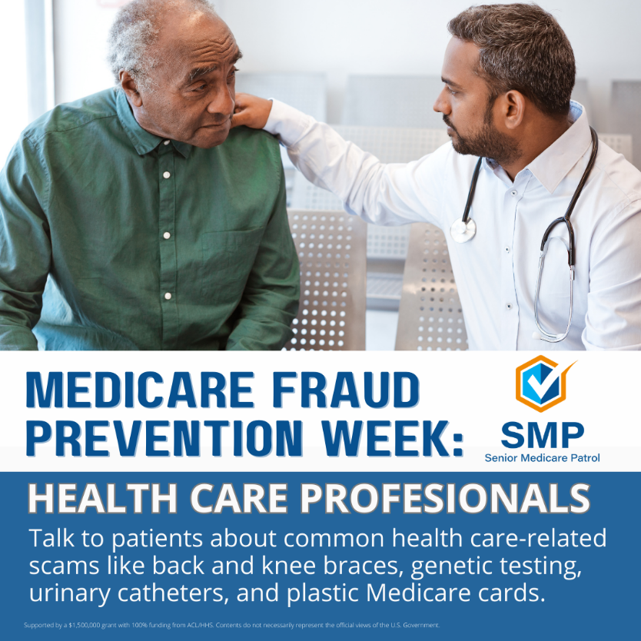
As a community, we can all participate in Medicare Fraud Prevention Week by looking out for our older neighbors and community members.  For example, when you are out in public, be aware of older people purchasing gift cards in large amounts. If you see this, ask questions or mention gift card scams. Many people have helped stop a scam in its tracks by stepping in and asking questions. #MedicareFraudPreventionWeek #MFPW | 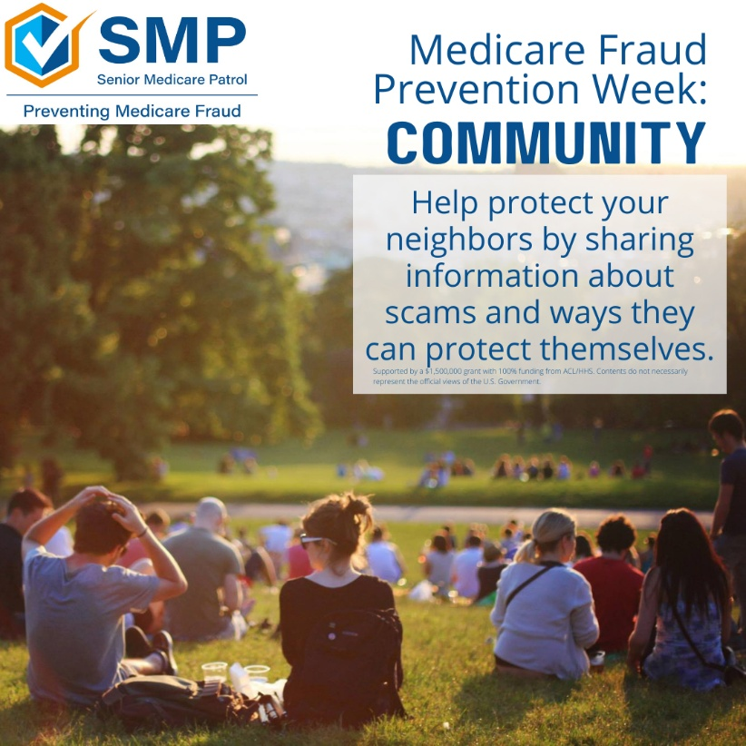
As a community, how can you help prevent Medicare fraud, errors, or abuse?  If you are out in public and overhear someone talking about Medicare, don’t be afraid to offer information about SMP and SHIP. These are trusted, unbiased government programs in every state ready to help Medicare beneficiaries, families, and caregivers. #MFPW #PreventDetectReport | 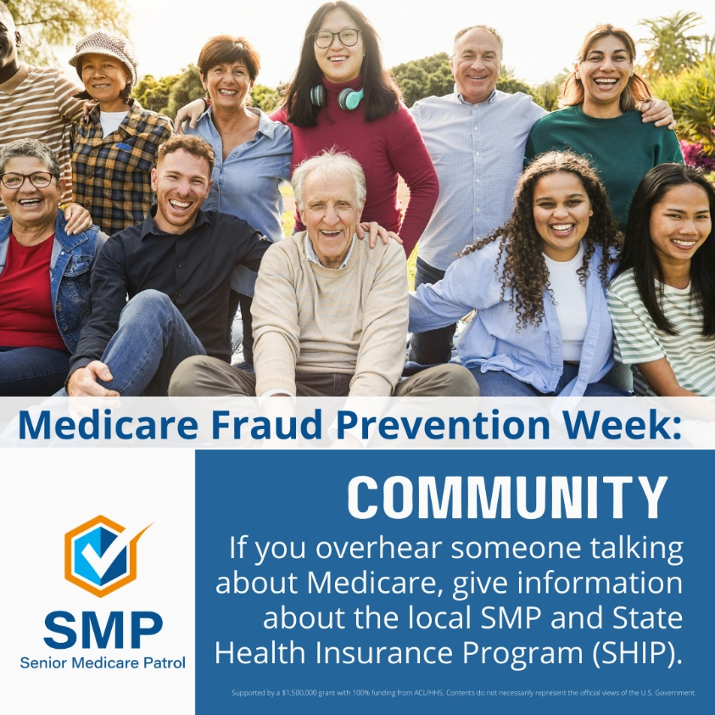
Back to Top

