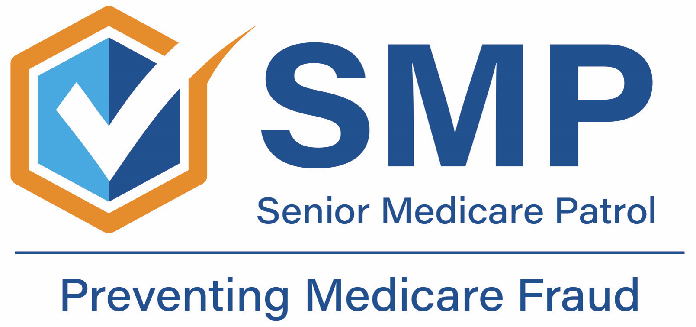
Contact Information
[INSERT ORGANIZATION NAME. INCLUDE SENIOR MEDICARE PATROL.]
[INSERT CONTACT NAME]
[INSERT PHONE NUMBER]
[INSERT EMAIL ADDRESS]
[INSERT WEB ADDRESS]
For Immediate Release:
(Date)
Medicare Fraud Prevention Week Runs the Week of 6/5
Everyone Can Prevent Medicare Fraud
(City, State) – Fraud costs Medicare an estimated $60 billion per year. It costs Medicare beneficiaries in time, stress, their medical identities, and even their health. It costs families, friends, and caregivers in worry and lost work when helping their loved ones recover from falling victim to Medicare fraud.
“Medicare fraud has a devastating impact on both beneficiaries and the Medicare program,” said [INSERT SMP CONTACT NAME AND TITLE HERE. Be sure to also include “Senior Medicare Patrol (SMP)”].
“We teach people how to avoid experiencing Medicare fraud. By preventing fraud from happening, this program helps individuals and protects the Medicare program for generations to come.”
Learn how to protect yourself and your loved ones by joining the Senior Medicare Patrol (SMP) and their partners for Medicare Fraud Prevention Week which runs the week of June 5, or 6/5, because most people become eligible for Medicare when they turn 65. Learn more about Medicare Fraud Prevention Week at www.smpresource.org.
###
SMPs help educate and empower Medicare beneficiaries in the fight against health care fraud. Your SMP can help you with your questions, concerns, or complaints about potential fraud and abuse issues. It also provides information and educational presentations.

